|  |  |
| --- | --- |
|  | **English 3**  Semester 1 Credit Recovery Opportunity  Springboard |

**Option 1: Unit 1, Embedded Assessment 2**

**Synthesizing the American Dream**

Assignment:

Your assignment is to synthesize at least three to five sources and your own observations to defend, challenge, or qualify the statement that America still provides access to the American Dream. This question requires you to integrate a variety of sources (three to five) into a coherent, well-written argumentative essay. Your argument should be central; the sources and your observations should support this argument.

|  |  |
| --- | --- |
| Planning and Pre-Writing | * What are the elements of a strong synthesis paper, and how can you use these elements as a sort of “to-do list” for your planning? * What texts from Unit 1 provide relevant evidence for your own answer to the essay prompt? |
| Drafting | * How will you clearly voice your position on the topic without overlooking the nuances and complexities of the topic? * What assumptions or beliefs are either spoken or unspoken in your sources? * How do the ideas in your selected sources relate to your position? Do they agree with, disagree with, or offer a sort of qualification to your ideas? |
| Evaluating and Revising | * Do you consistently show how each selected quote from your sources relates to your central position? * How can you make sure that your syntax is sophisticated and varied, especially the openings of your sentences? * Are your ideas sequenced in the best way to guide your reader through your ideas and present a convincing argument? How could reordering some of your ideas improve this? |
| Editing and Publishing | * How will you check for grammatical and technical accuracy? * What sort of outside resources can help you to check your draft (e.g., a style guide such as MLA, a dictionary)? * How will you prepare yourself to present this essay to an audience? |

Reflection:

After completing this Embedded Assessment, think about how you went about accomplishing this assignment and respond to the following:

* In what ways did your various sources validate your ideas about the American Dream, and in what ways did they add new elements or depth to your thinking?

Resources:

This Embedded Assessment is the culmination of Unit 1, Part 2. This portion of the unit begins on Page 101 of the English 3 Student Edition.

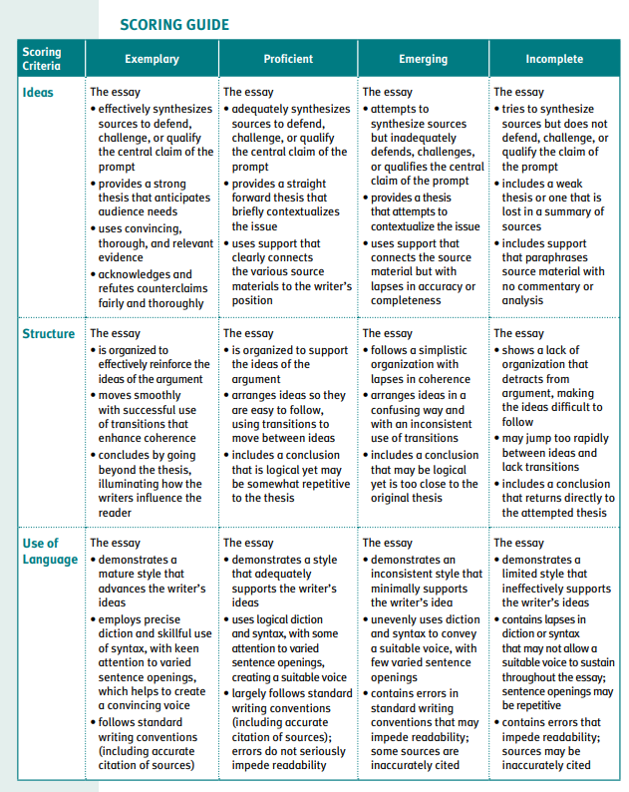

**Option 2: Springboard Writer’s Workshop Argumentative Essay**

Argumentative Writing

Learning targets:

* Analyze the characteristics of argumentative writing, and evaluate a writer’s use of reasoning and evidence to support a claim.
* Use knowledge of the writing process to plan, write, revise, and edit an argumentative essay that supports claims with valid reasoning and relevant evidence.
* Introduce and develop claims and counterclaims effectively, anticipating the knowledge, concerns, values, and possible biases of the audience.
* Use an organizational structure and transitional words, phrases, and clauses that make the relationships between claims, counterclaims, reasons, and evidence clear.
* Craft writing that effectively employs figurative language or hyperbole.
* Edit drafts to conform to standard English conventions.
* Participate collaboratively during discussions by contributing relevant ideas and information, building on others’ ideas, and moving the discussion forward with thoughtful questions and responses.

Preview:

In this workshop, you will work with your teacher and classmates to construct two arguments that respond to a specific perspective. You will then use these as models as you write an argumentative essay independently.

Activity 1: Discovering the Elements of an Argumentative Response Essay

Addressing Opposing Points

1. Honing skills in civil debate and diplomatic argumentation is important in many careers and fields. When trying to convince others of your point of view and calling on them to take action, it is especially important to understand the logic of the opposition. Think of the last time that you engaged in a debate or disagreement about a worthy topic. Was your understanding of the other point of view strong enough to respond with a rebuttal based on logic and reason? How did you address the opposing point of view effectively?

As You Read

* Underline key ideas, and reread any sections that you do not understand at first.
* Highlight phrases and clauses that contribute to the author’s tone.
* Jot down notes and any questions that you may have in the margins.

Background Information: The following letter of veto (a form of rebuttal) is an example of formal argumentation, responding to legislation passed by the Illinois State Senate. The author, Adlai Stevenson (Illinois governor, 1949– 1953), maintains a professional persona while expressing his opinion that Bill No. 93 is ridiculous.

Sample Text: Argumentative Response

To the Illinois State Senate by Adlai E. Stevenson

1 To the Honorable, the Members of the Senate of the Sixty-sixth General Assembly:

2 I herewith return, without my approval, Senate Bill No. 93 entitled “An Act to Provide Protection to Insectivorous Birds by Restricting Cats.” This is the so-called “Cat Bill.” I veto and withhold my approval from this bill for the following reasons:

3 It would impose fines on owners or keepers who permitted their cats to run at large off their premises. It would permit any person to capture, or call upon the police to pick up and imprison, cats at large. It would permit the use of traps. The bill would have statewide application—on farms, in villages, and in metropolitan centers.

4 This legislation has been introduced in the past several sessions of the Legislature, and it has, over the years, been the source of much comment—not all of which has been in serious vein. It may be that the general assembly has now seen fit to refer it to one who can view it with a fresh outlook. Whatever the reasons for passage at this session, I cannot believe there is a widespread public demand for this law or that it could, as a practical matter, be enforced.

5 Furthermore, I cannot agree that it should be the declared public policy of Illinois that a cat visiting a neighbor’s yard or crossing the highway is a public nuisance. It is in the nature of cats to do a certain amount of unescorted roaming. Many live with their owners in apartments or other restricted premises, and I doubt if we want to make their every brief foray an opportunity for a small game hunt by zealous citizens—with traps or otherwise. I am afraid this Bill could only create discord, recrimination and enmity. Also consider the owner’s dilemma: To escort a cat abroad on a leash is against the nature of the cat, and to permit it to venture forth for exercise unattended into a night of new dangers is against the nature of the owner. Moreover, cats perform useful service, particularly in rural areas, in combating rodents—work they necessarily perform alone and without regard for property lines.

6 We are all interested in protecting certain varieties of birds. That cats destroy some birds, I well know, but I believe this legislation would further but little the worthy cause to which its proponents give such unselfish effort. The problem of cat versus bird is as old as time. If we attempt to resolve it by legislation who knows but what we may be called upon to take sides as well in the age-old problems of dog versus cat, bird versus bird, or even bird versus worm. In my opinion, the State of Illinois and its local governing bodies already have enough to do without trying to control feline delinquency.

7 For these reasons, and not because I love birds the less or cats the more, I veto and withhold my approval from Senate Bill No. 93.

Working from the Text

2. RAFT is an acronym for a strategy used to respond to and analyze texts. Using this strategy can help the reader understand the relationship among the following elements: Role of the author, Audience, Format, and Topic. If only one element is changed or adjusted, the text can take on an entirely different complexity. Begin by identifying the following elements from the sample text:

R—Role of the author

A—Audience

F—Format

T—Topic

Check Your Understanding

Examine the specific phrases and clauses that you highlighted. How would you categorize the tone of this letter? Why does Stevenson choose to approach this topic with this tone? What is the intended effect of this approach?

*For the purpose of this assignment, we are skipping activities 2 and 3 which require group/class writing.

Activity 4: Independent Writing

WRITING PROMPT: Locate a published, publicly filed lawsuit or proposed bill that inspires you to respond with a rebuttal. Then respond to the ideas expressed in the piece in a well-crafted argumentative letter or essay. Review the writing steps from the class-constructed response, and apply them to your response.

Refer to the Scoring Guide for this writing task—it will help you understand where to focus your attention and efforts.

Planning and Prewriting:

1.

|  |  |
| --- | --- |
| Claims | Potential Rebuttals and Evidence that Could Be Employed to Respond to This Claim |
|  |  |
|  |  |
|  |  |

2. To augment your evidence, spend time researching credible online sources as well as conducting informal interviews. Search for both primary and secondary sources. Your goal here is to search out information that represents the entire range of relevant perspectives on this lawsuit—not just your own.

3. Once you have found additional sources, consider their relevance, validity, and reliability. If you deem your new information relevant, valid, and reliable, add the information to your brainstorm list so you can accurately represent these viewpoints in your class-constructed text.

To consider your sources’ relevance, validity, and reliability, think about the following questions:

* Relevance and Validity: Does the information appear to be legitimate? Is it timely and closely connected to the rebuttal? In what ways could this evidence be used to support the ideas generated for response?
* Reliability: Are the author’s name and qualifications clearly identified? Is the information from a respected source of publication? If it is an online resource, is the site listed as .gov, .edu, or .org rather than .com?

4. Once you have compiled a list of relevant, valid, and reliable evidence, choose two to three of the most compelling and precise pieces of evidence and share them with the class.

5. After everyone has submitted their best evidence, you will have a solid representation of a range of views and information on the topic. As a class, use the synthesized information to construct an outline that will frame the response.

Drafting:

6. Remember that part of your task is to maintain formal style while exposing the absurdity of this case. This is crafted not only into what you write but also how you write it. The tone you strike will have a great deal of impact on the effectiveness and ethos of your response. Before you begin drafting, come to an agreement as a group about how to promote this style in your response. This selection will influence your choices regarding diction, syntax, and rhetorical appeals/devices.

7. Draft the introduction, or opening paragraph, of the response. Remember that while this will take the form of a letter of response, the forum is public and the appeals should be directed at a broader audience than just Lloyd as an individual.

8. Draft the body paragraphs and conclusion or closing.

Check Your Understanding:

After you have completed this process, read over the drafted response that you created. Use these questions as a checklist:

* Does the introduction clearly establish your group’s position and the topic of contention?
* Are the strongest points of argument in the lawsuit adequately addressed?
* Does the diction and syntax maintain decorum while promoting the specified tone desired?
* Does the writing expose the absurdity of holding small children liable for stray throws?
* Is the tone effective for the purpose and audience?
* Do transitions help the reader clearly make connections among the ideas of the response?
* Is the response organized in the most effective way to convince the audience?

Resources:

The full activities are found within the English 3 Writers Workshop Student Edition. Pages 15-24.

